REFERRAL

**BSB receives:**

1. **information/complaint received by BSB raising question of whether a barrister is unfit to practise; or**
2. **Disciplinary Panel/Tribunal considers barrister may be unfit to practise; or**
3. **Barrister requests referral.**

Representations sought from barrister re referral

**PROCESS CONCLUDES**

**PROCESS CONCLUDES**

**PROCESS CONCLUDES**

**Examination by an Appointed Medical Adviser appointed by the President of COIC**

Require medical records to be released to Full Hearing

**BSB CC decision to refer to Medical Panel, applying “realistic prospect” test (i.e.: establishing that the barrister’s fitness to practise is seriously impaired to a degree justifying restrictions on practice).**

HEARINGs

**Medical Panel convened by President of COIC: QC Chair; x2 barristers, a medical expert and a lay panellist.**

**Medical Panel - Preliminary Hearing to consider need for:**

* **Directions for full hearing**
* **Interim suspension (public protection /wider public interest)**
* **Restrictions on practice (public protection /wider public interest).**

**Medical Panel - Full Hearing: may decide to:**

* **Take NFA; or**
* **Allow the barrister to practise subject to conditions; or**
* **Indefinitely suspend the barrister.**

REVIEW / APPEAL

**Review Panel – Hearing to consider any change in circumstances.**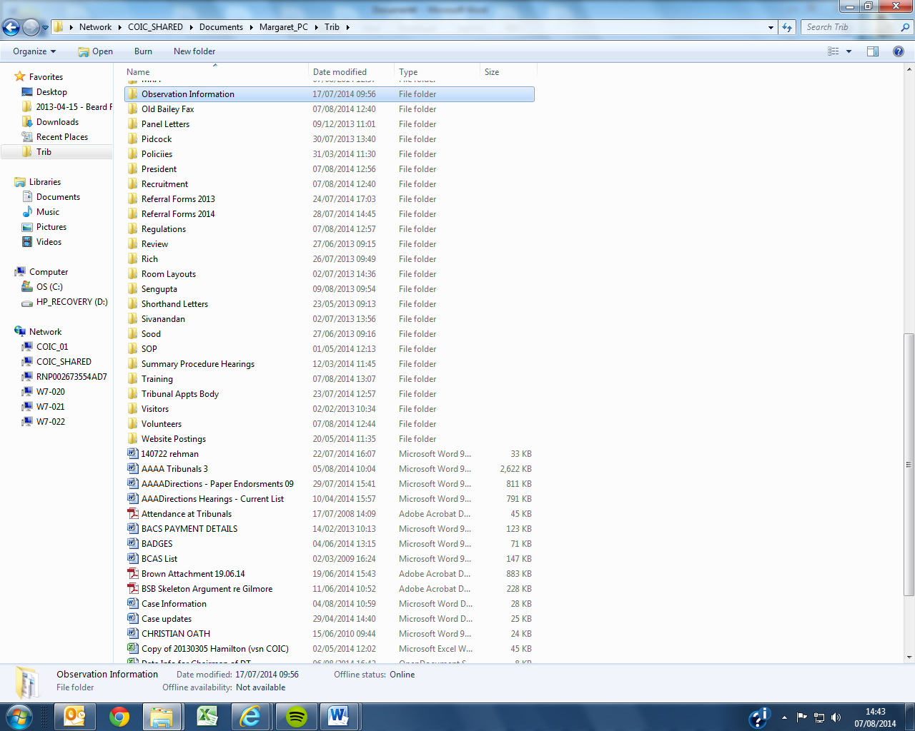

**Appeal Panel – Hearing to consider any challenge of Medical Panel’s decision.**

**No direction given.**

**Interim Suspension/interim prohibition from accepting/ public access instructions imposed.**

**Barrister offers voluntary undertaking not to practise/accept public access instructions pending criminal case/disciplinary proceedings concluding.**

CONCLUSION