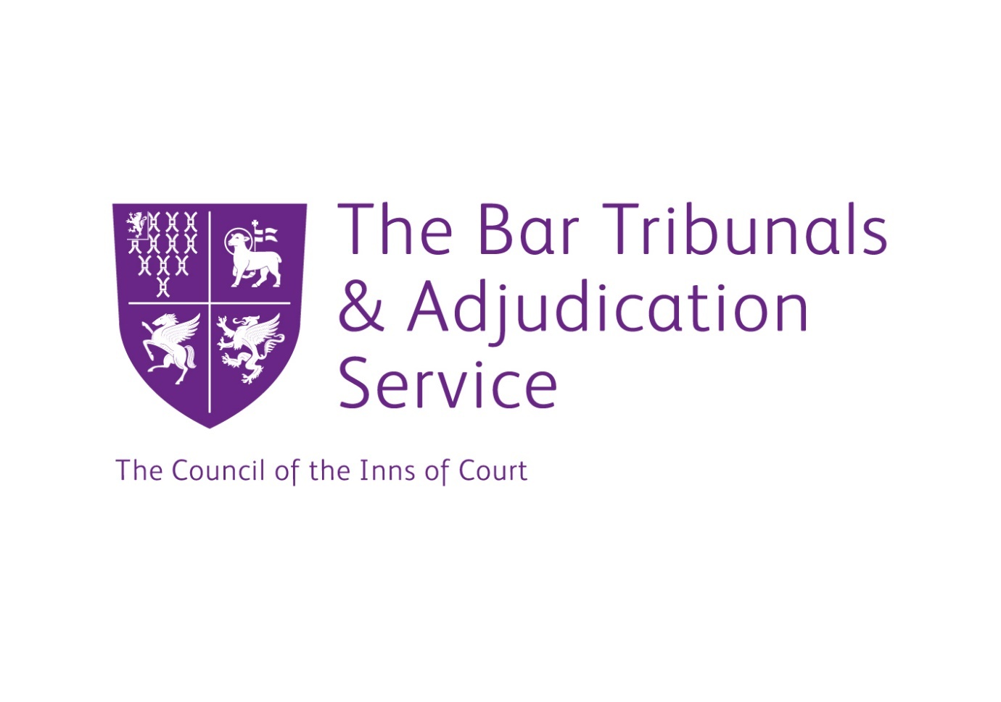

FOR IMMEDIATE RELEASE: 29 April 2021

Review of BTAS Sanctions Guidance

The Bar Tribunals & Adjudication Service (BTAS) today issued a consultation document [Sanctions Guidance review - Consultation paper] seeking initial views on proposed revisions to parts of the BTAS Sanctions Guidance. The Guidance is used to guide Disciplinary Tribunals when considering the appropriate sanctions to impose following findings of professional misconduct against barristers. The responses to this consultation will inform the contents of the final draft Guidance which will be subject to a further, second consultation commencing in July 2021.
The consultation seeks the views of the profession and the public as to:

- The levels for fines and suspensions
- A clearer stepped approach to deciding sanctions
- Thirteen new misconduct “Groups” for the indicative sanctions
- A revised approach to recommended indicative sanctions and
- Proposed sanction ranges for five of the thirteen proposed specific “Groups” of misconduct: dishonesty; misconduct of a sexual nature; discrimination and non-sexual harassment; behaviour towards others; and social media. The consultation document also includes an indication of the potential ranges for the other eight Groups, but the final ranges for these Groups will be formally determined in light of the responses to the consultation and included in the second consultation.

The proposals in the consultation document have been developed by a Working Group led by the Chair of the Tribunals, HHJ Jonathan Carroll, and including the Registrar of BTAS, lay and barrister members of the BTAS Disciplinary Tribunal panel, the BSB’s Director of Legal and Enforcement and the Head of Investigations and Enforcement at the BSB. The proposals also reflect research by the Working Group into the approaches of other regulators, a survey of current users of the Guidance and a review of recent cases, sanctions and case law.
Announcing the consultation, the Chair of the Tribunals, HHJ Jonathan Carroll, said “For the past year we have been engaged in the first comprehensive review of our Sanctions Guidance since 2014 and the consultation document we have published today is the fruit of much research and discussion within our Working Group. We are very conscious of the great interest there is in these issues, and of some of the concerns which have recently been expressed, and we hope that everyone with an interest in these important matters will take part in this consultation.”

ENDS
Notes for Editors
About BTAS
On behalf of the President of the Council of the Inns of Court (COIC), BTAS is responsible for the appointment, operation, and decisions (including sentencing) of disciplinary tribunal panels under a Services Agreement between the BSB and COIC. The BSB is responsible for bringing charges of professional misconduct against barristers, which BTAS tribunals then adjudicate. The sanctions imposed are a matter for the tribunal having regard to BTAS Sanctions Guidance.
Sanctions Guidance has been developed by BTAS in collaboration with the BSB for use by members of BTAS’s Disciplinary Tribunals when considering what sanctions should be imposed in cases of a proven breach of professional misconduct under the terms of the BSB Handbook. The current Guidance can be found here https://www.tbtas.org.uk/wp-content/uploads/2019/10/BTAS-Sanctions-Guidance-2019.pdf.
Responding to the Sanctions Guidance Consultation
The consultation will run for six weeks from Thursday 29 April 2021 to Monday 14 June 2021.

Responses should be sent to Margaret Hilson, the Bar Tribunals Administrator

By email to consultation@tbtas.org.uk

By post to: Bar Tribunals and Adjudications Service
Gray’s Inn Square
London
WC1R 5JD

Those wishing to provide their responses by telephone may do so by prior arrangement with Margaret Hilson at the addresses above or on 020 3432 7348.

Unless a respondent has asked to keep their response confidential, BTAS will summarise the responses received and will publish the summary document on the BTAS website.

